# In-Class Practice – Day 16 (Data Types and Data Functions)

**Converting Dates and Numbers to String for formatting**

1. Copy/Paste and run the statement below and then format according to the examples below

**select sysdate as unformatted,**

**sysdate as formatted1,**

**sysdate as formatted2,**

**sysdate as formatted3,**

**sysdate as formatted4**

**from dual;**

* 1. *formatted1:* OCT-2019
  2. *formatted2:* October 23, 2019 *Note: ignore extra space to right of month for now. We’ll work on that later*
  3. *formatted3*: 10/23/19 06:10:01
  4. *formatted4*: WED, 10-23-2019

1. Copy/paste and run the statement below and then format according to the examples below. Add lines as needed

**select invoice_total as unformatted**

**,invoice_total as formatted1**

**from invoices;**

* 1. *formatted1*: $999.99
  2. *formatted2*: In this example see if you can fix the ### issue arising in formatted1
  3. *formatted3*: In this example copy the format of the previous column but remove decimals

**Using String functions to format characters**

1. Copy/paste and run the statement below and then format according to the examples below. Add lines as needed

**select vendor_name,**

**vendor_state,**

**to_char(invoice_date,'Month DD, YYYY') as invoice_date,**

**invoice_total**

**from vendors v inner join invoices i**

**on v.vendor_id = i.vendor_id**

**order by v.vendor_name;**

* 1. Update vendor_name to be ALL CAPS
  2. Update vendor_state to by lowercase
  3. Trim the trailing spaces after the invoice_date Month. *Hint: You’ll have to trim Month by itself and concat to the other day and year part of the date.*
  4. Left pad invoice_total with 15 periods (e.g. ‘.’)

NOTE: You should end up with something like this:

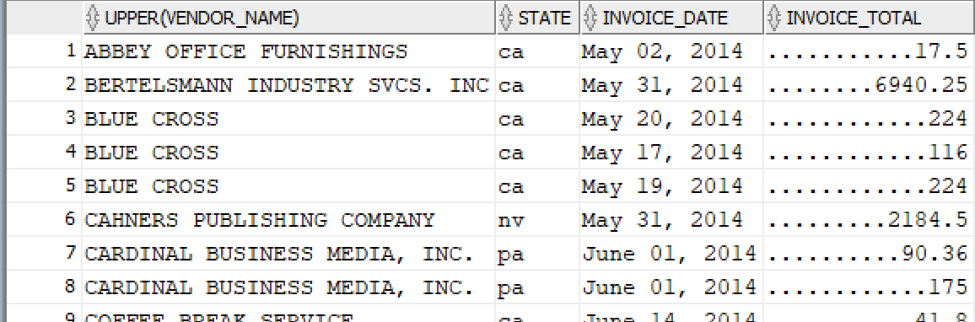

**More character Functions**

1. Copy/paste and run the statement below and then format according to the examples below. Add lines as needed

**select vendor_phone as unformatted_phone,**

**vendor_phone as phone_replace,**

**vendor_phone as phone_substr,**

**vendor_phone as phone_length**

**from vendors ;**

* 1. Update the 2nd phone like so (i.e 800-555-1205) using the REPLACE function. *Hint: You can nest a function inside another function.*
  2. Update the 3rd phone the same way (i.e. 800-555-1205) using the SUBSTR function
  3. Update the 4th phone to just return the LENGTH of the cell value.

1. Select the product_name from the Products table. We want you to parse the first word of the column into a second column called *Brand* which contains the first word in the product_name. After you do this parse the all text that comes after the first blank space in product_name into a 3rd column called *Instrument_Name.* ***Hint: You’ll want to consider using a combination of INSTR and SUBSTR for this***

**Numeric functions**

1. Copy/paste and run the statement below and then format according to example output shown in picture

**SELECT 12.4999 as Round_Whole,**

**12.4999 as Round_Decimal,**

**12.4999 as Format_TRUNC**

**FROM DUAL;**

Result:

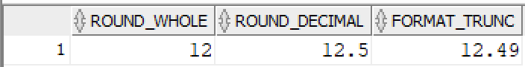

**Date Functions**

1. Copy/paste and run the statement below and then format according to instructions below

**Select SYSDATE - TO_DATE('01-JAN-22') as Days_since_New_Year,**

**SYSDATE - TO_DATE('01-JAN-22') as Days_Rounded**

**from DUAL;**

* 1. Update 2nd date to be rounded to a whole number
  2. Add a 3rd column that uses the MONTHS_BETWEEN function to capture the number of months between today’s date and Jan 1 of this year
  3. Add a column that returns today’s date plus 30
  4. Add a column that uses the ADD_MONTHS function to add one month today’s date.

**Date/Time Searches**

1. Select all records from the **date_sample** table where the start_date is Feb-28-06. If you get no records consider how the timestamp affects this and how you should update your query to account for that.

**CASE Function – Simple**

1. Select the product_name and list_price from products. Add a third column that uses a CASE based on the category_id column that returns the following:
   1. When category_id is 1, return 'Guitars'
   2. When category_id is 2, return 'Bass'
   3. When category_id is 3, return 'Drums'
   4. When category_id is 4, return 'Keyboard'

Once you have the CASE working, update query to sort by category_name price ascending

Results should look something like this:

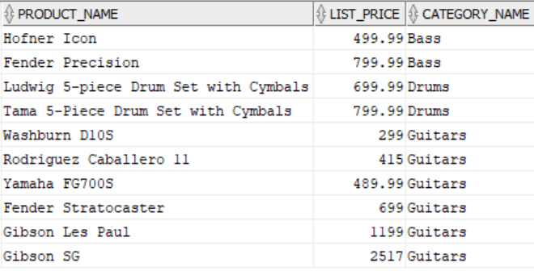

**CASE Function – Search**

1. Select the product_name and list_price from products. Add a third column that uses a CASE that makes the following evaluations: *Hint: You will need to use a search Case so that slightly changes the syntax.*
   1. When list_price >= 1000, return 'Professional'
   2. When list_price >= 500, return 'Intermediate'
   3. Everything else, return 'Beginner'

Results should look something like this:

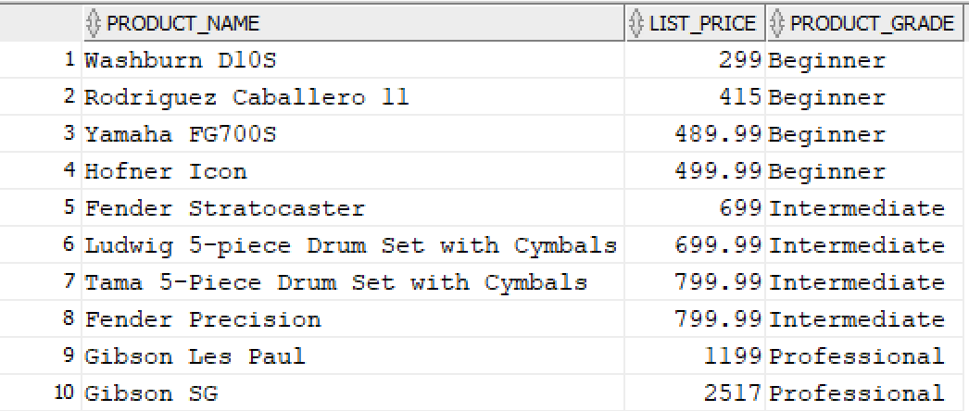

**Handling Nulls**

1. Pull a report that checks vendor contact is up-to-date like so. *Hint: Use NVL for this*

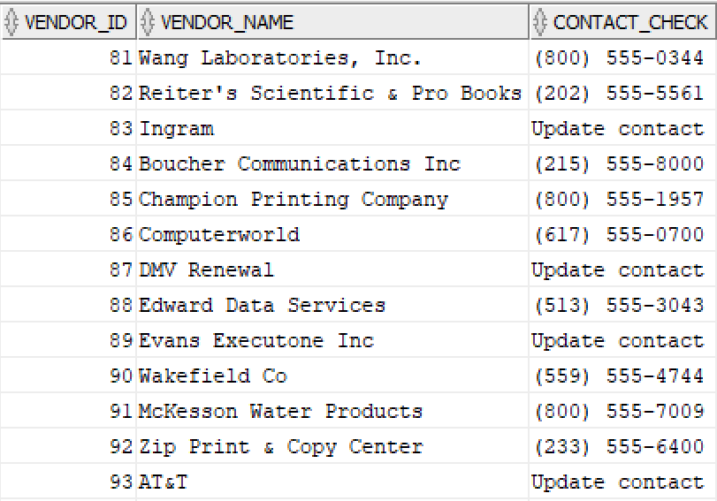

1. Make a copy of the previous query and update it to use the NVL2 function to show not null values as ‘Okay’ and then sort by contact_check. Results will look something like this

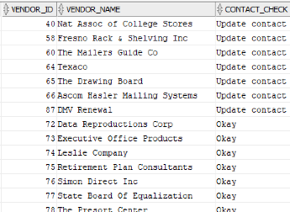

**RANK and DENSE RANK**

1. Pull a list of products (name and list price) and their rank by list_price descending. Results should look like this for RANK.

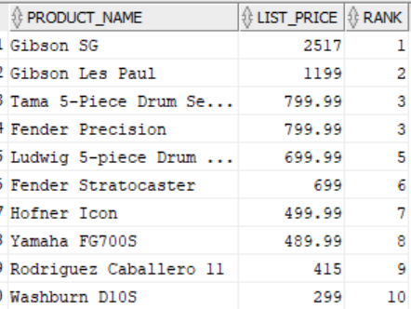

NOTE: Try using DENSE_RANK and discuss the difference with RANK.

**Row Number**

1. Try running the query below:

SELECT ROW_NUMBER() OVER(ORDER BY vendor_name)

AS row_number, vendor_name

FROM vendors;

After you run the query make this query output an in-line view. That means I want you to make the query a subquery. i.e. SELECT * FROM (subquery)

**If you get done early…you can either help out your neighbors OR work on extra practice below**

1. Without using the slides to help you, update the code to use the ANSI standard CAST function to convert the data in the same way it’s currently doing it

**SELECT invoice_id,**

**invoice_date,**

**invoice_total,**

**to_char(invoice_date) AS varchar_date,**

**to_number(invoice_total) AS integer_total**

**FROM invoices;**

1. Write a query that returns an output like this

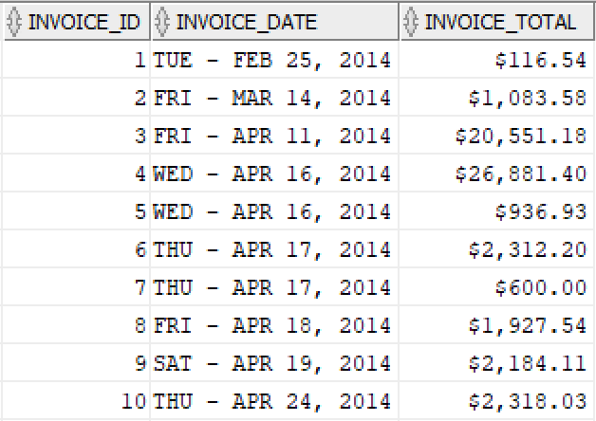

1. Copy/paste and run the statement below and then format according to instructions below

**select SYSDATE as current_hour,**

**SYSDATE as hours_left**

**from dual;**

* 1. Update current_hour column to return only the current hour using the HH24 mask
  2. Update the hours_left column to return the hours left in the day